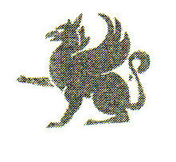
PHILADELPHIA
MUSEUM
OF ART

Box 7646, Philadelphia, PA 19101-7646 • Tel. 215-763-8100 • Fax: 236-4465

COPYIST PERMISSION FORM

Date: _________________________________________________________________________

Work Being Copied: ____________________________________________________________
(Artist)

____________________________________________________________
(Title)

____________________________________________________________
(Gallery Number, or description if number unknown)

Name of Copyist: ____________________________________________________________

Home Address &
Telephone Number: ____________________________________________________________
(cell phone if you
will have one in the
gallery with you)
____________________________________________________________

School (if applicable) ____________________________________________________________

How long will you be working in the galleries: ________________________________________

________________________________________________________________________________

Start Date, and days of the week you plan to work: ____________________________________

________________________________________________________________________________

Name of professor or reference: _______________________________________________

Cc: Herb Lottier
Security Desk _________________________________________
(APPROVAL/CURATOR)

